Live Auction #6
Ladysmith Staycation / Company Coming?
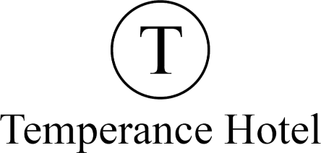
Temperance Hotel - 2 Nights Accommodation (Expires March 31, 2025)
The newly restored Temperance Hotel is an award-winning Heritage Boutique Hotel located in picturesque and historic downtown Ladysmith. This premiere destination has 5 large executive suites available, each offering unique characteristics with a mix of modern amenities and repurposed materials that have been salvaged from the renovation and purposely applied to enhance each space.
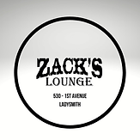
Zacks Lounge - Gift Certificate

Zack's Lounge is located on the award winning 1st Avenue in the beautiful little town of Ladysmith. Zack’s is well known for their hand crafted cocktails and fresh local cuisine.
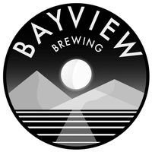
Bayview Brewing Company - Growler and Gift Certificate
Your new mid-island stop for creative sour beers and artisan eats! The beer lineup features classic ales such as a blonde, pale ale, Saison, west coast IPA, and hazy IPA. Their specialty is creating interesting sour beers, particularly dessert sours, lending to Jonny’s 25+ year career as a chef.

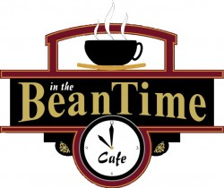
In the Beantime - Gift Certificate
In the Beantime Cafe opened at 18 High Street in Ladysmith in 2006 and specializes in fresh homemade from scratch food which is featured in all our breads, desserts, menu items and feature meals, and fresh roasted coffee.

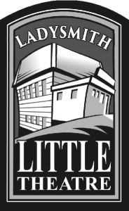
Ladysmith Little Theatre - 2 Tickets for a 24-25 Performance
Ladysmith Little Theatre started as the dream and vision of residents Judi and Terry Whittaker. They wanted to provide quality, accessible community theatre for Ladysmith and the surrounding communities. Today, everyone involved in our productions is a member volunteer.

